# Staff Report

Meeting Date: February 6, 2024

To: Siskiyou County Board of Supervisors

From: Hailey Lang, Planning Director

Subject: Proposed Zone Change (Z-23-02) to rezone APN 028-530-070 from Heavy Industrial (M-H) to Rural Residential Agricultural (R-R) and a Tentative Parcel Map (TPM-23-02) creating four new parcels at 6.79 acres, 6.57 acres, 3.95 acres, 3.75 acres and a remainder parcel of 2.27 acres

## Background

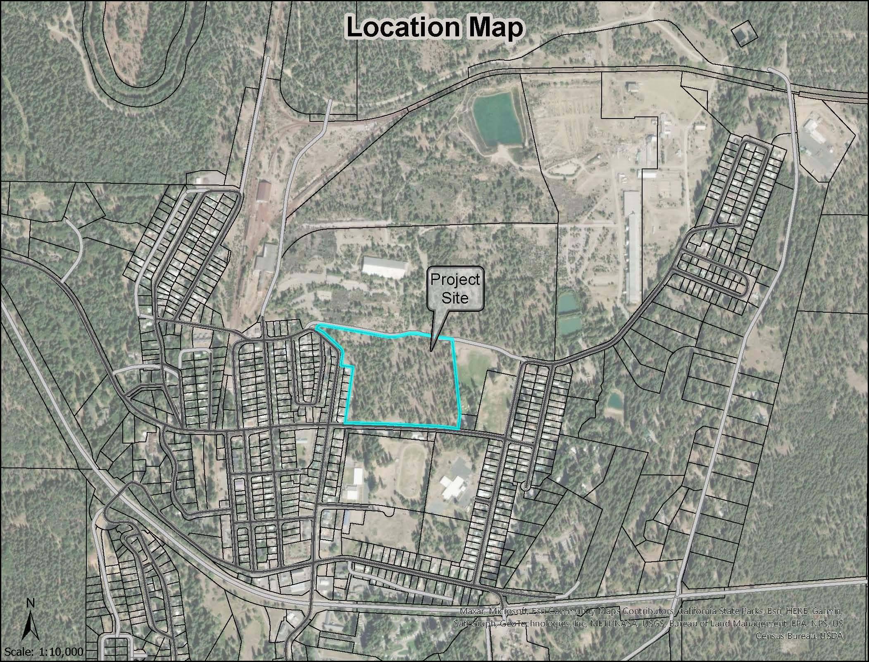

**Figure 1: Project Location Map**

The project site is located in the unincorporated community of McCloud. It is bounded by Mill Road on the north and East Colombero Drive to the south. The subject parcel is a legal parcel that was legally created as Parcel 4 of Parcel Map Book 7 at Page 192 for Champion International Corporation. The parcel was subsequently modified by Boundary Line Adjustment, which was recorded August 25, 1986, as Document No. 1986-0010050 in Siskiyou County Official Records.

Property owners McCloud Partners LLC have applied for a tentative parcel map to subdivide a 23.8-acre, currently undeveloped, parcel into four parcels and a remainder parcel. Parcel sizes are as follows: Parcel A, 6.57 acres; Parcel B, 6.79 acres; Parcel C, 3.95 acres; Parcel D, 3.75 acres, and a remainder parcel of 2.72 acres. In order to facilitate the tentative parcel map, the property owners have applied for a zone change to replace the current Heavy Industrial (M-H) zone district with the Rural Residential Agricultural, 2.5-acre minimum parcel size to facilitate the development of the project site in a manner that would be consistent and compatible with the uses to the west, south and east of the project site.

## Analysis

**General Plan, Subdivision, and Zoning Consistency**

The Land Use Element of the Siskiyou County General Plan identifies the project site as being with the mapped resource overlay areas for Building Foundation Limitation, Soils: Severe Septic Tank Limitations, Flood Hazard, Wildfire Hazard, and Woodland Productivity. Planning staff has identified that Composite Overall Policies 41.3(e), 41.3(f), 41.5 through 41.9, and 41.18 apply to the proposed project.

Pursuant to Siskiyou County Code Section 10-4.105.3 and 10-6.5501, the proposed lots are consistent with all County lot design standards. The proposed subdivision of the existing parcel is compatible with the surrounding area. The neighboring parcels are a combination of residentially zoned subdivisions with parcel sizes of approximately 7,000 square feet, a public park and elementary school. The proposed parcel sizes ranging between 3.75 acres and 6.79 acres fit within that range and provide a lower density buffer to the Heavy Industrial uses to the north of the project site.

With the approval of Zone Change (Z-23-02) from Heavy Industrial (M-H) Rural Residential Agricultural, 2.5-acre minimum parcel size the primary use of the land will be residential which will be consistent with surrounding uses and as such will clearly not be disruptive or destroy the intent of protecting each mapped resource.

## Environmental Review

Staff evaluated the project’s potential for environmental impacts by reviewing the project relative to Appendix G of the CEQA Guidelines. Based on this review, it was determined that the subdivision of the property, as proposed, would not adversely impact the environment.

The proposed tentative parcel map would potentially result in four additional single-family primary dwellings, accessory structures on the proposed parcels with the potential to construct additional Accessory Dwelling Units in the future.

Because there is not substantial evidence, in light of the whole record before the County, that the proposed vesting tentative parcel map may have a significant effect on the environment, staff recommends that the Planning Commission find the project exempt from the California Environmental Quality Act (CEQA) Guidelines pursuant to Sections 15061(b)(3). CEQA Section 15061(b)(3) states that “CEQA applies only to projects which have the potential for causing a significant effect on the environment. Where it can be seen with certainty that there is no possibility that the activity in question may have a significant effect on the environment, the activity is not subject to CEQA.”

## Comments

No comments were received at the time this staff report was written.

## Recommended Action

As detailed in Resolution PC 2023-024, it is the recommendation of the Planning Commission that the Board of Supervisors Determine the Project Exempt from the California Environmental Quality Act and Approve the McCloud Partners Zone Change (Z-23-02) and Tentative Parcel Map (TPM-23-02) by Adopting a Draft Ordinance Rezoning 23.8 acres (APN 028-530-070) from M-H to R-R-B-2.5

Should the Board of Supervisors concur with the recommendation of the Planning Commission, the Board of Supervisors must adopt an ordinance amending Zoning District Map 10-6.205-529. A draft motion to this effect is provided below.

## Recommended Motion

## I move to take the following actions:

1. Introduce, waive, and approve the first reading of the proposed ordinance reclassifying land southeast of the community of McCloud, off Mill Road and amending Zoning District Map 10-6.205-529; and
2. Direct the Clerk to schedule a continued public hearing on adoption of the CEQA exemption and a second reading of the ordinance.

## Attachments

1. Draft Ordinance No. _______, an Ordinance of the County of Siskiyou, State of California, Reclassifying Land Southeast of the community of McCloud, off Mill Road on APN 028-530-070; Township 39N, Range 2W, Section 1 & 6, MDB&M
2. Exhibit A: Zoning Ordinance Map
3. Planning Commission Staff Report – December 20, 2023
4. Signed Resolution PC 2023-024